**Sales Bot Flow:**

**The bots are stored in production machine in the root D:\work\RY_WORKSPACE_Bots.In this folders sub folders like dev and prod has the development and testing bots respectively.**

* **erp_opening_bot**

**This is used to open the erp by entering the UserId and Password.**

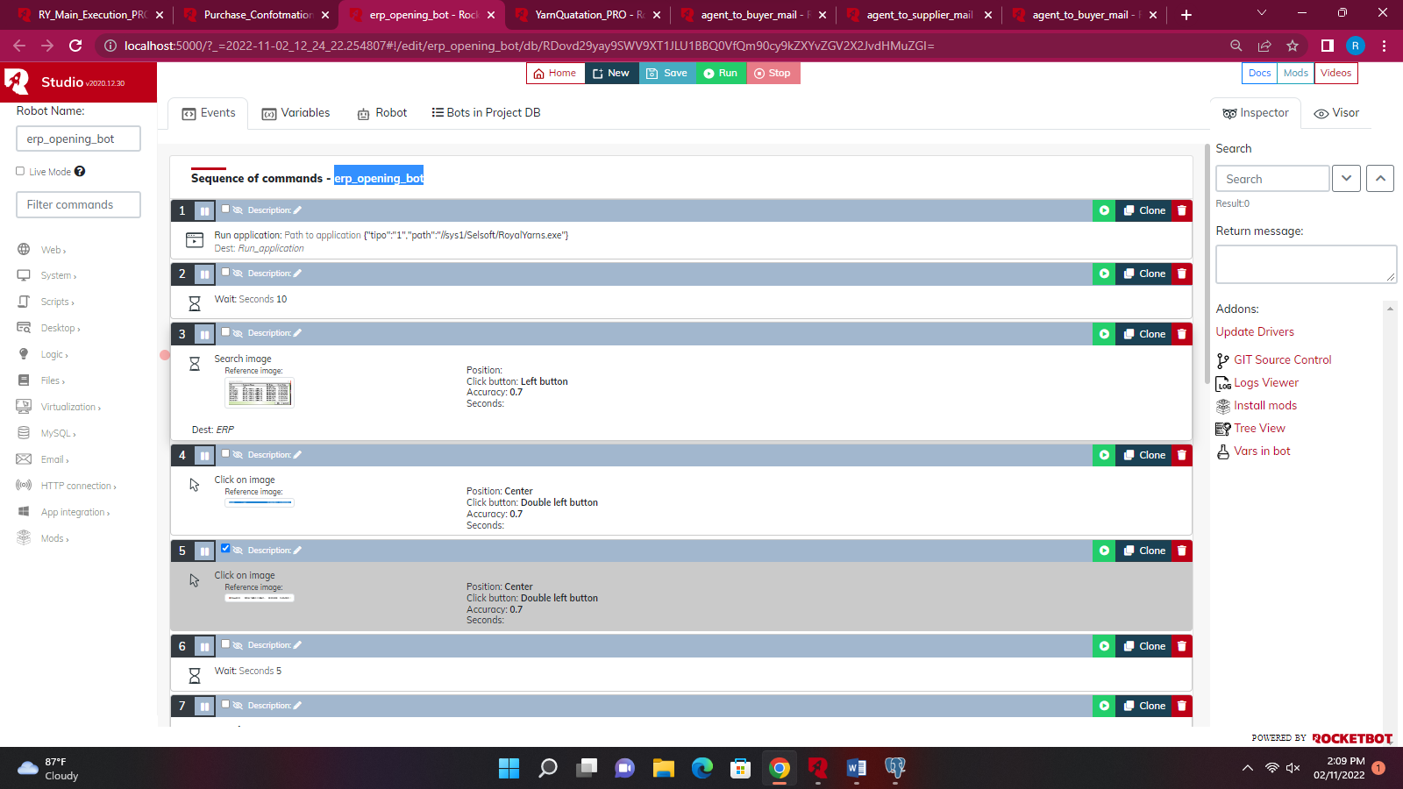

* **RY_Main_Execution_PRO**

**This the main bot which runs continuously which checks the status in the database then it executes the bot accordingly to the status.**

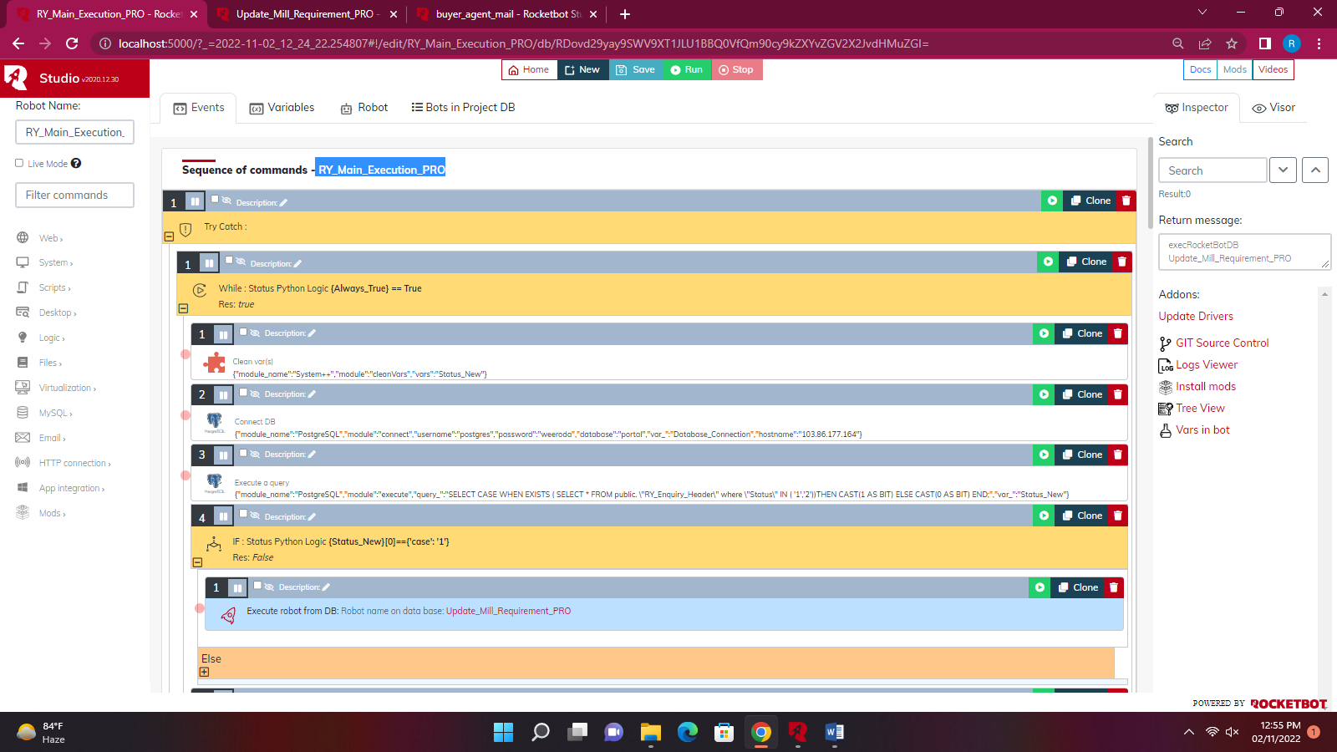

* **RY_MILL_REQUIREMENT_READING_PRO**

**This bot checks the enquiry email in the outlook then it reads the data in the email. It checks the data format in mail whether the data is in the form of table or non-table format. It reads the data of mail and enter it in the erp and saves the in the database with the status of ‘0’.**

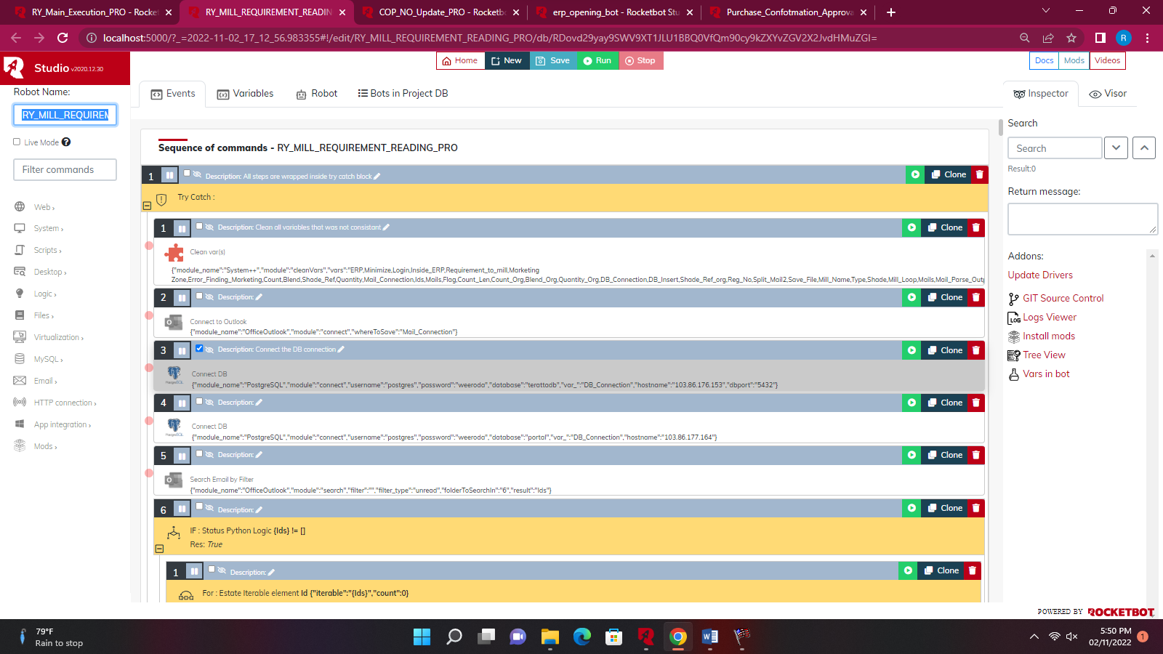

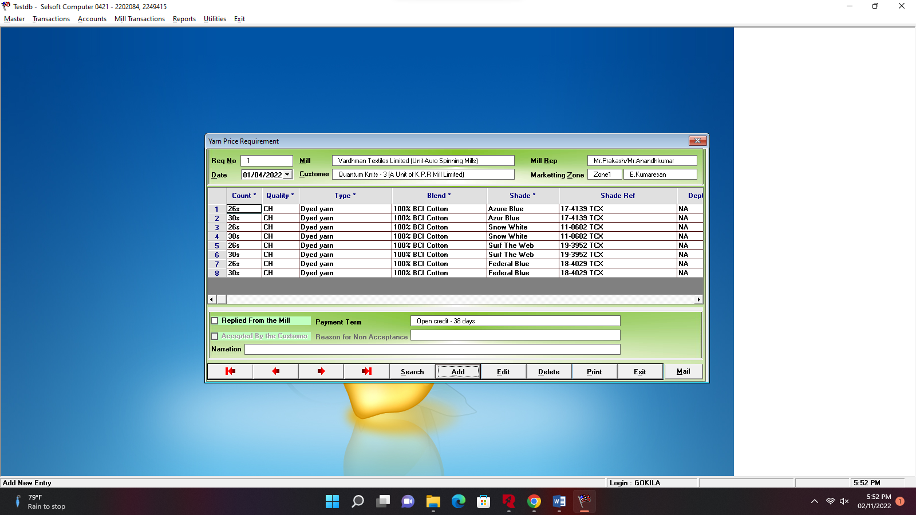

* **Update_Mill_Requirement_PRO**

**This checks the status of (1&2) in the database. If the condition gets satisfied then the updated data from the portal is updated in the erp with respect to the regno. Then it update the status to ‘3’.Then mail is send to supplier through the sub bot agent_to_supplier_mail**

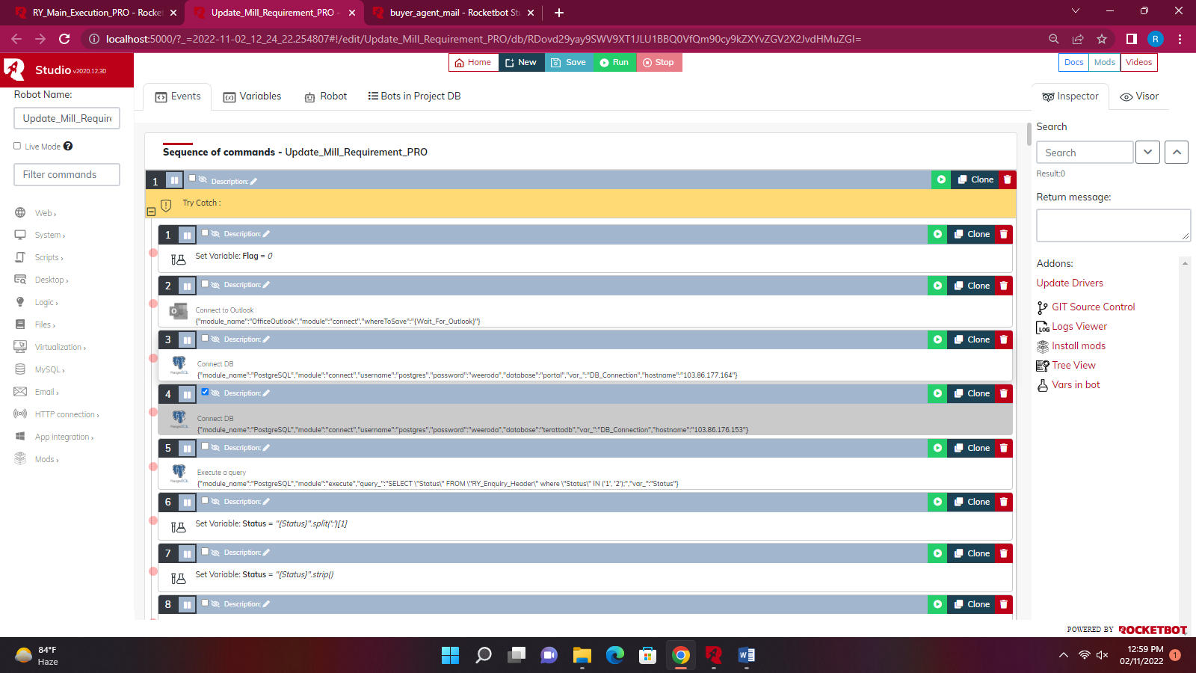

* + **agent_to_supplier_mail**

**This bot reads the email ids of supplier in the database and sends a mail which has the link of the terata website to them to seek for the price from them.**

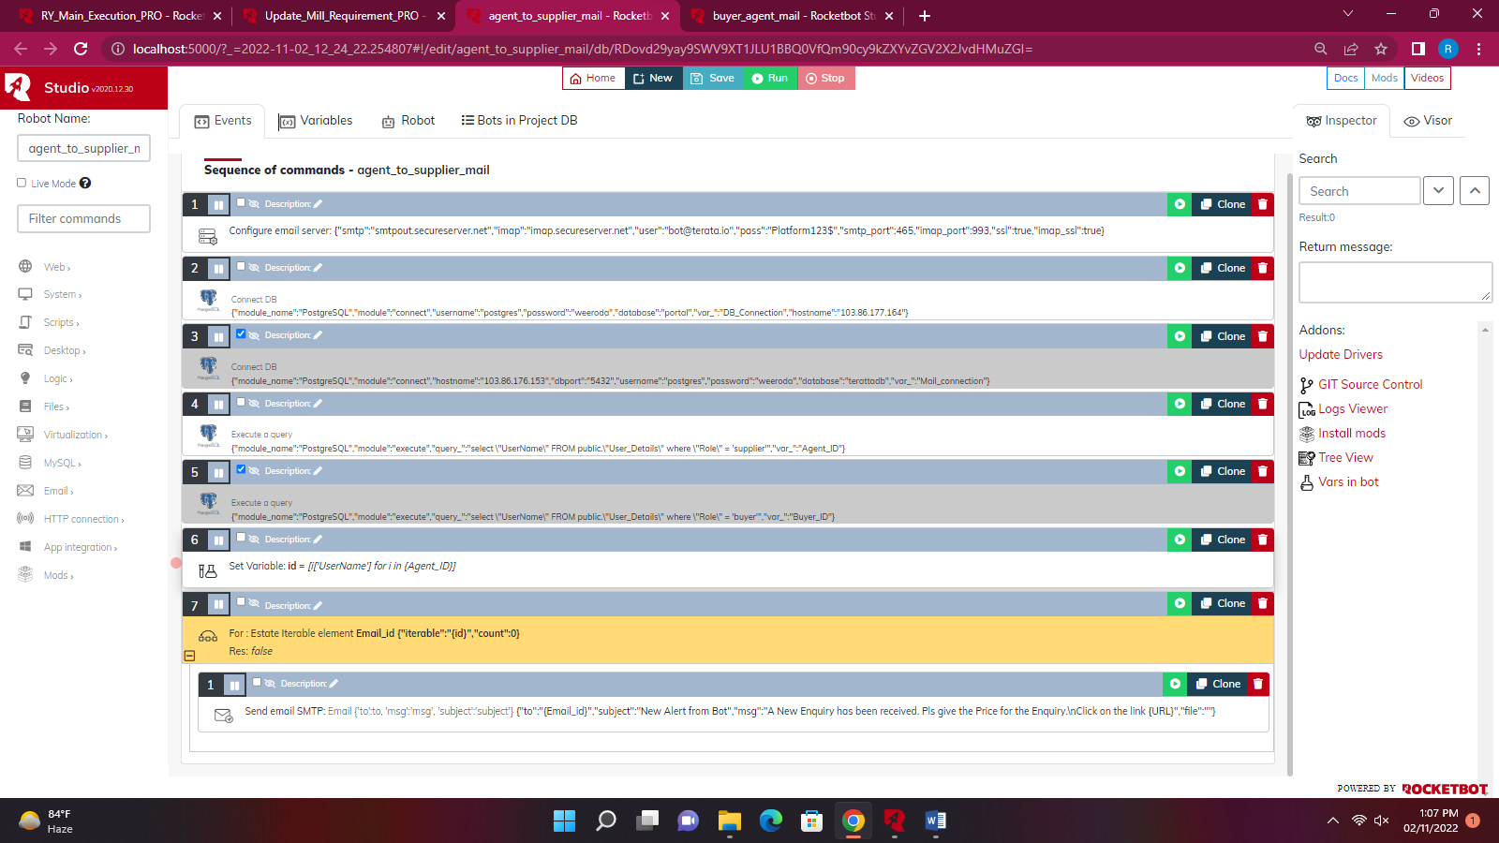

* **YarnQuotation_PRO**

**This checks the status of ‘5’ in the database. erp_opening_bot get executed Then yarn quotation Form from the erp is filled with the required details.**

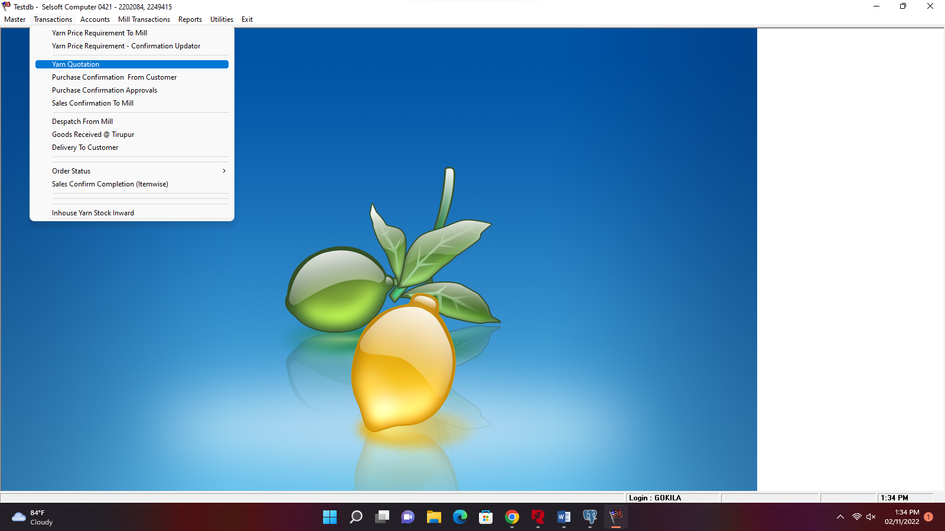

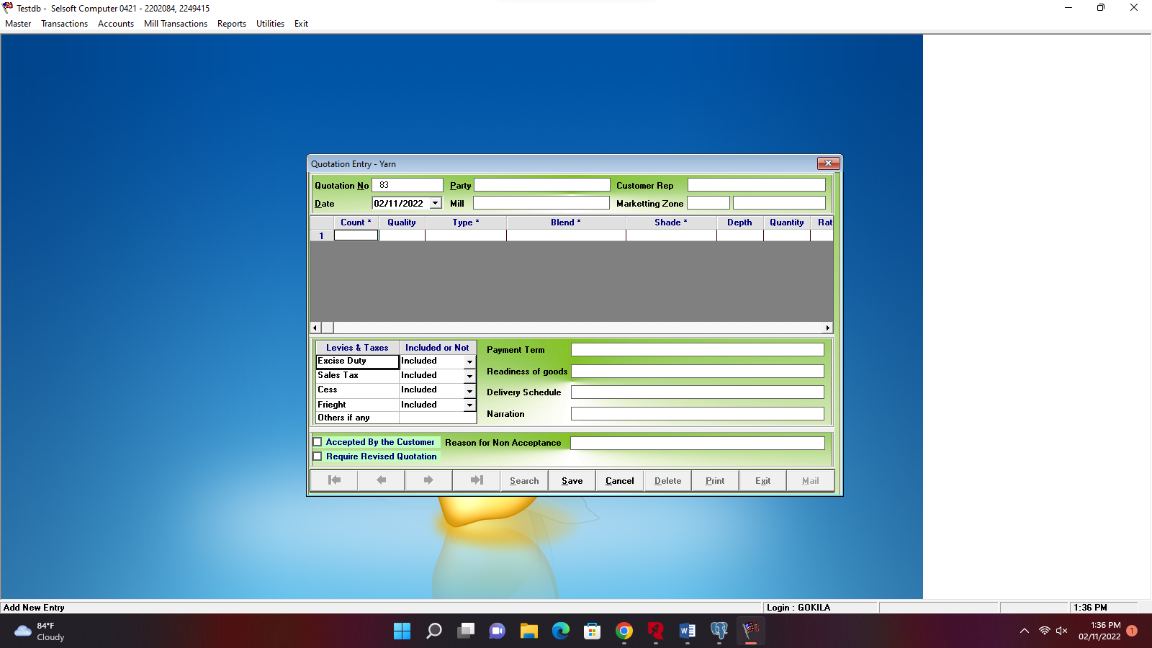

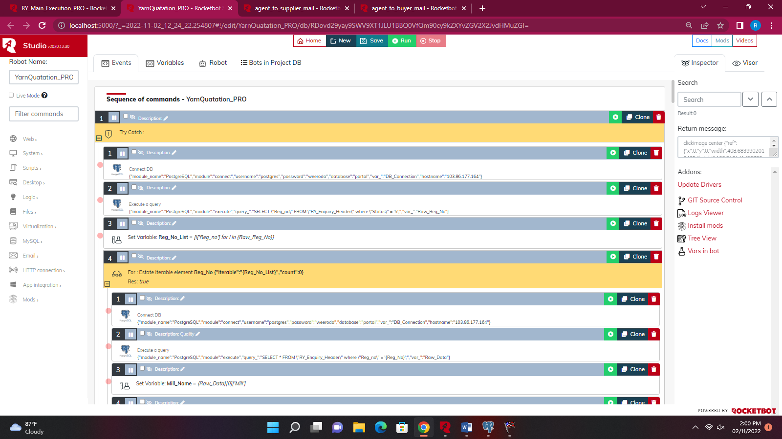

**Then it update the status to ‘6’.Then mail is send to buyer through the sub bot agent_to_buyer_mail.**

* + **agent_to_supplier_mail**

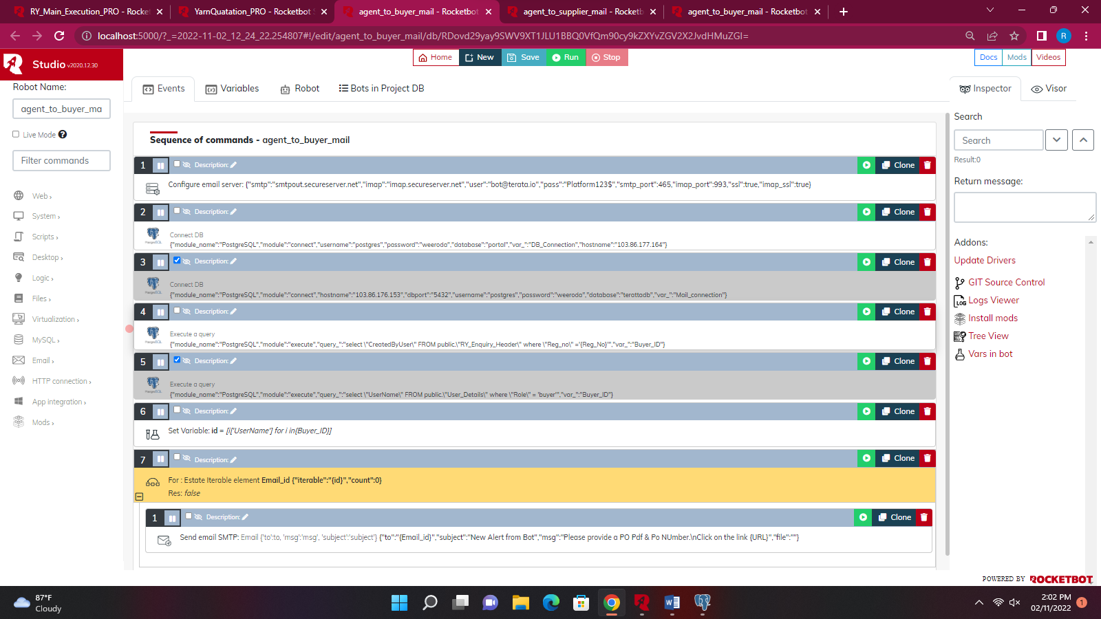

* **Purchase_Conformation_to_Customer_PRO**

**This checks the status of ‘8’ in the database. erp_opening_bot get executed Then Purchase Confirmation from Customer from the erp screen gets executed. This changes the status from ‘8’ to ‘9’.**

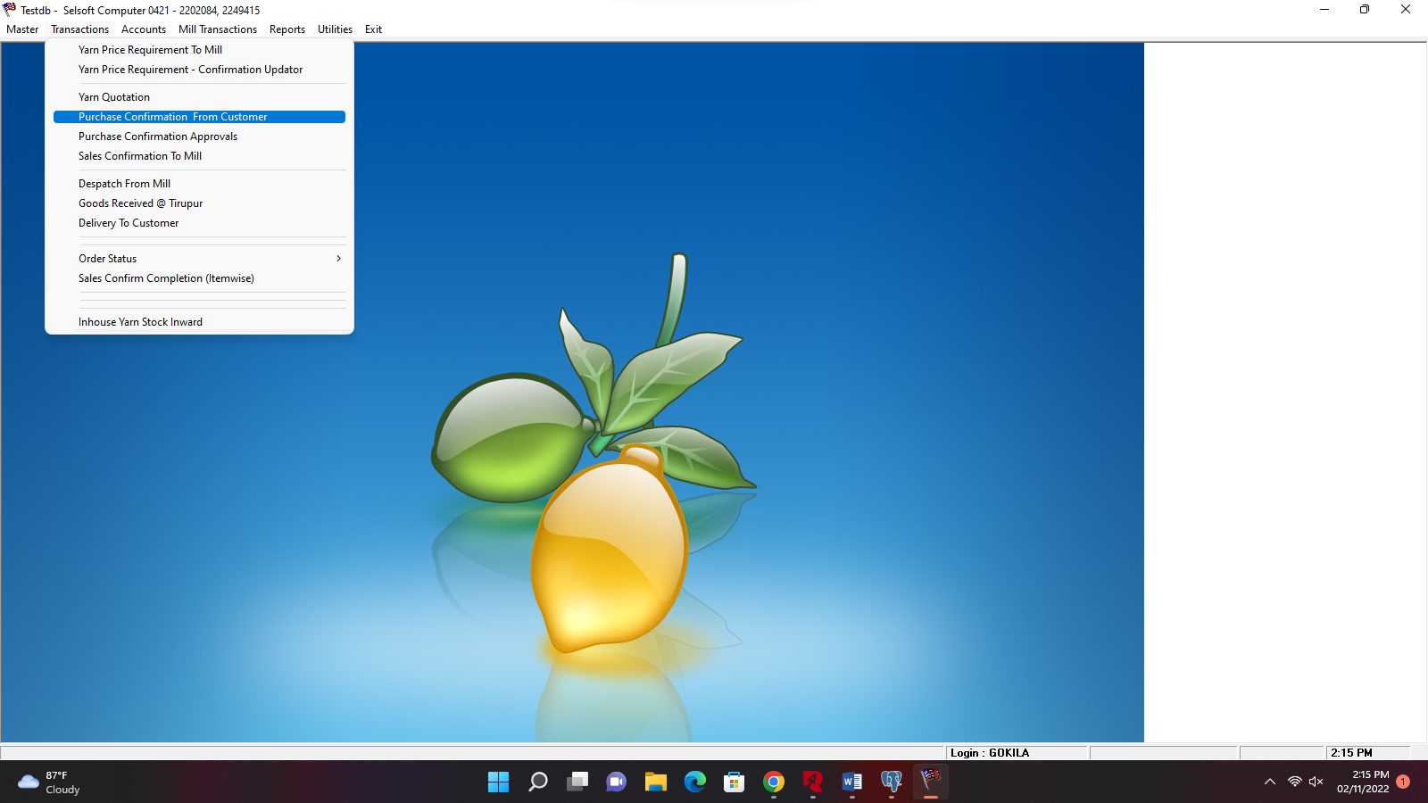

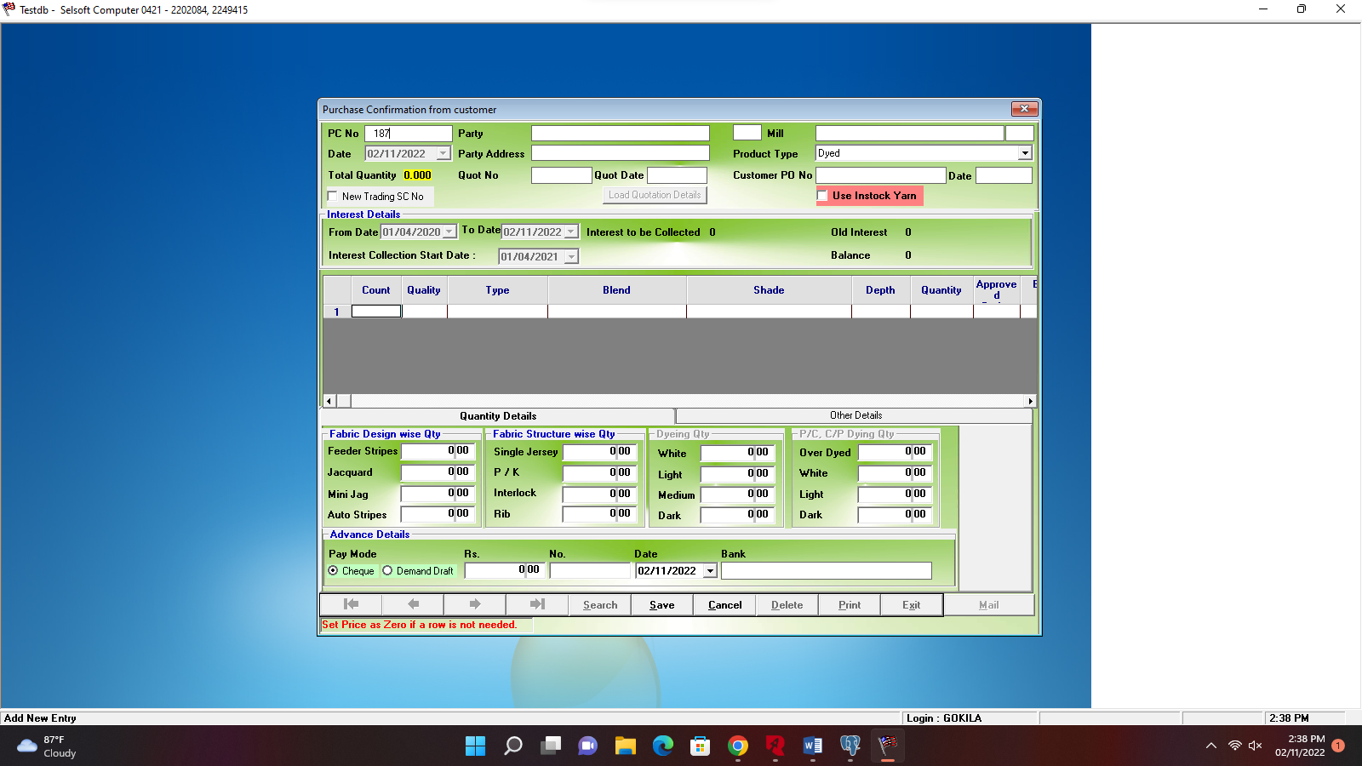

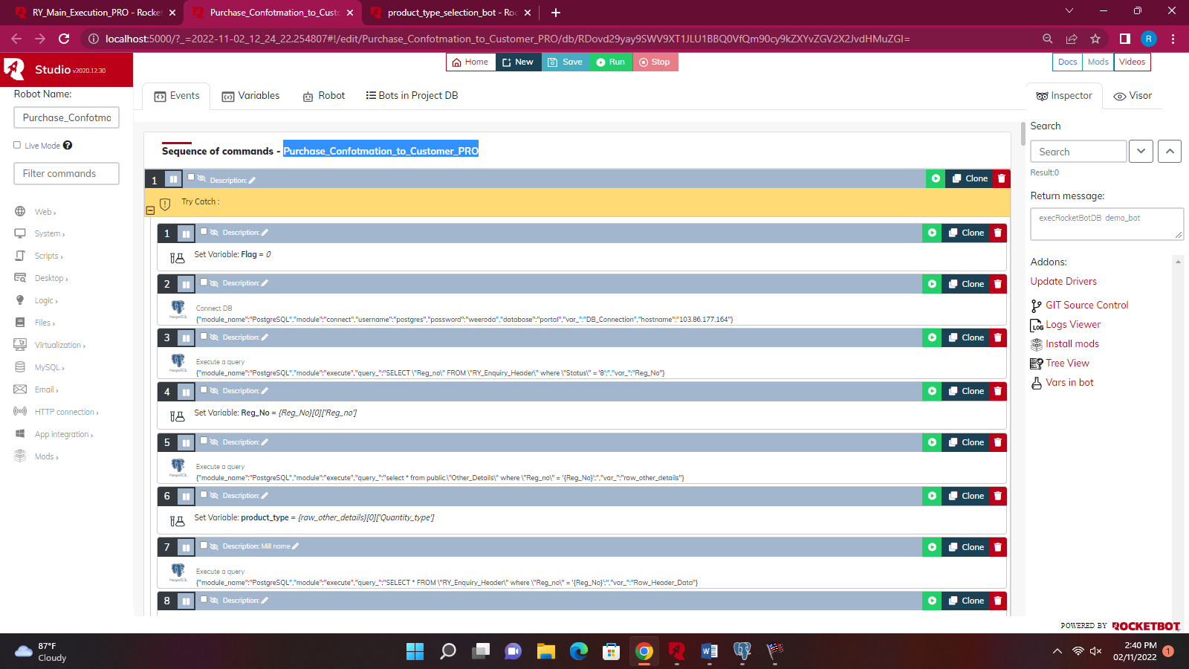

* + **product_type_selection_bot**

**This bot is used to select the product type in the erp screen with respect to the data from the database.**

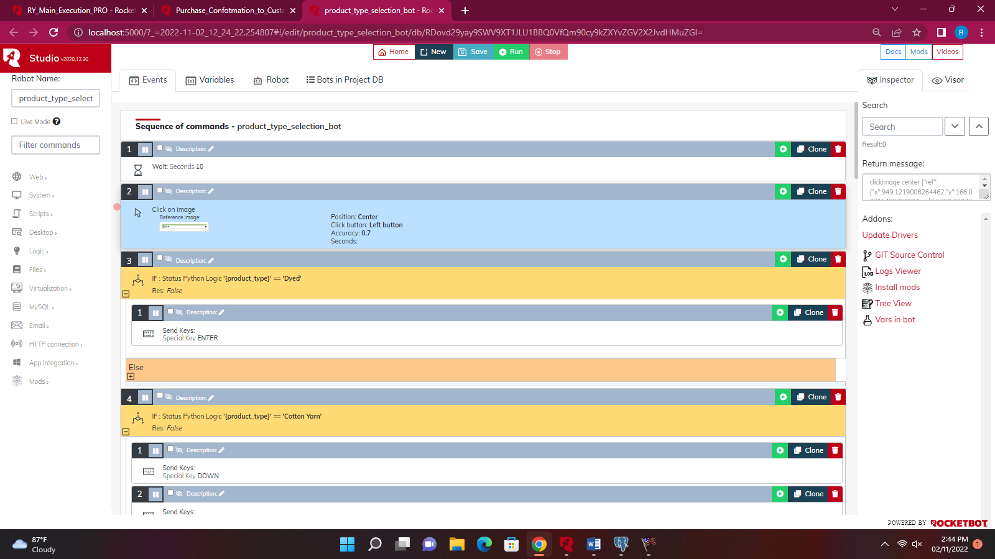

* + **data_entry_with_product_type**

**This bot is used to enter the quantity details according to the product type selected by the product_type_selection_bot**

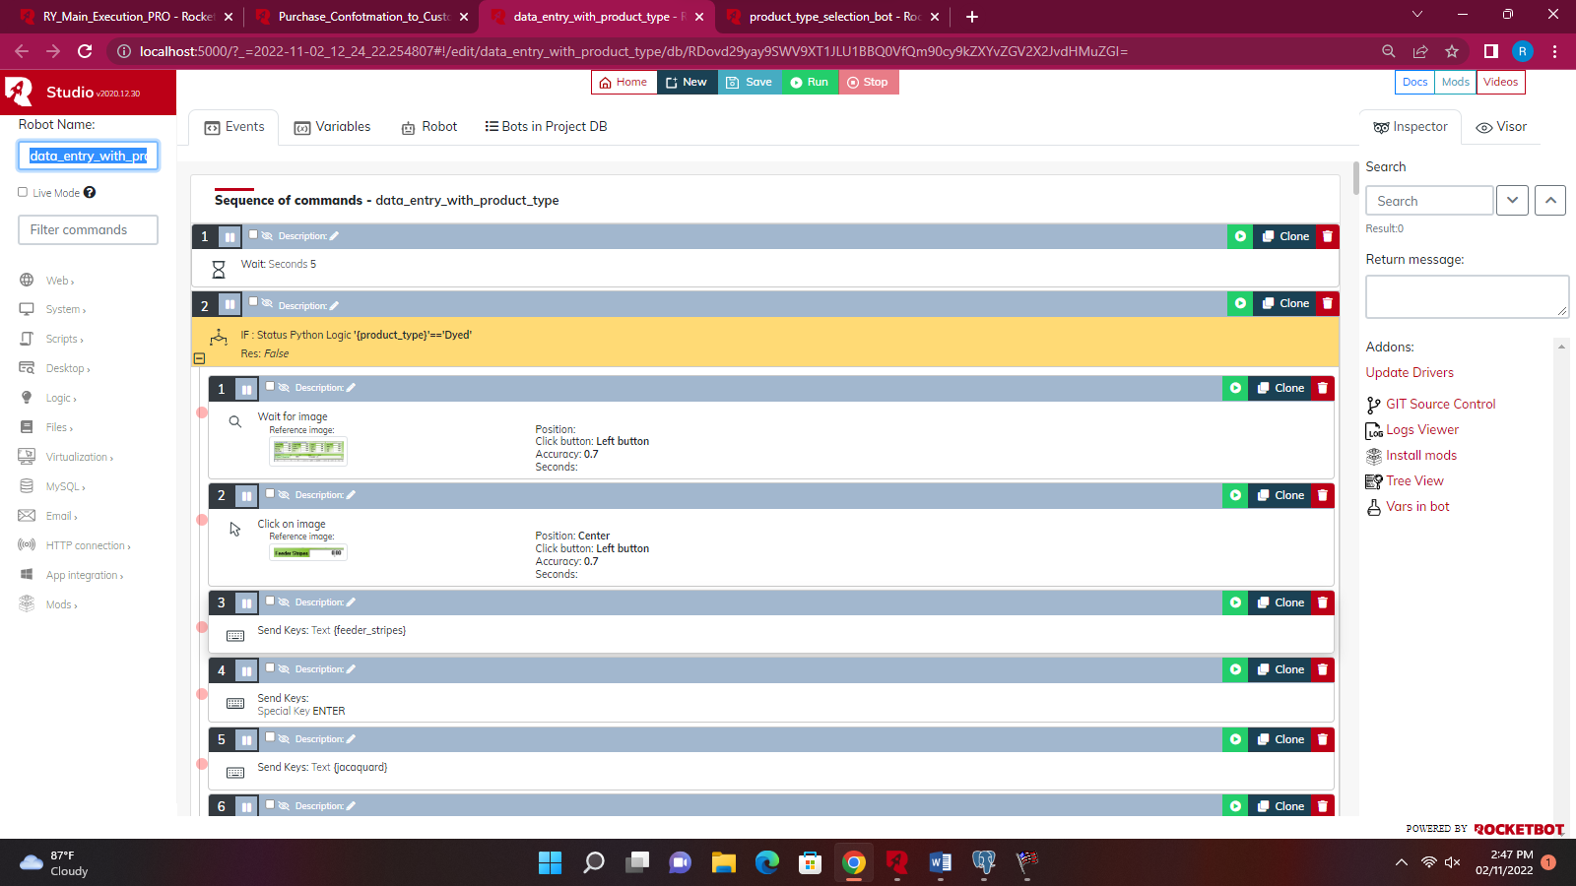

* **Purchase_Conformation_Approval_send_To MD**

**It is used to send the purchase approval to the MD through the erp. And the status gets updated from ‘9’ to ‘10’.**

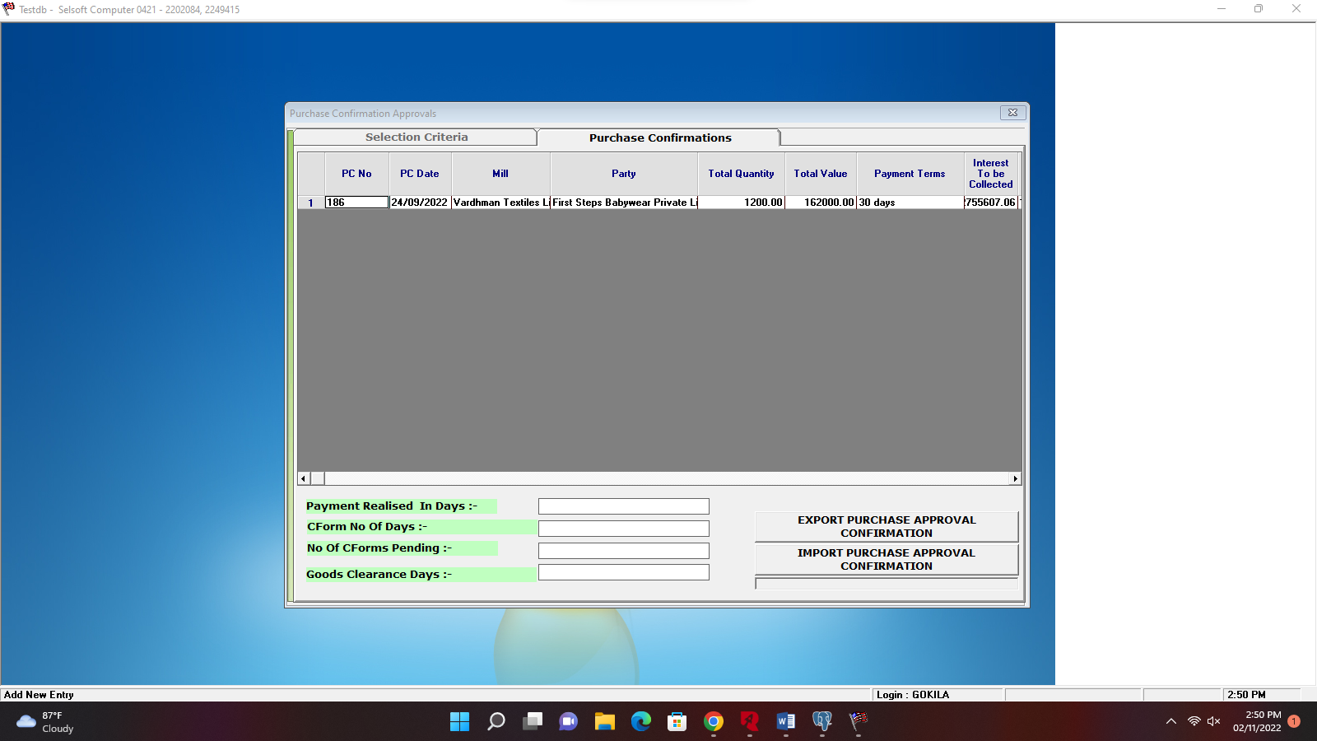

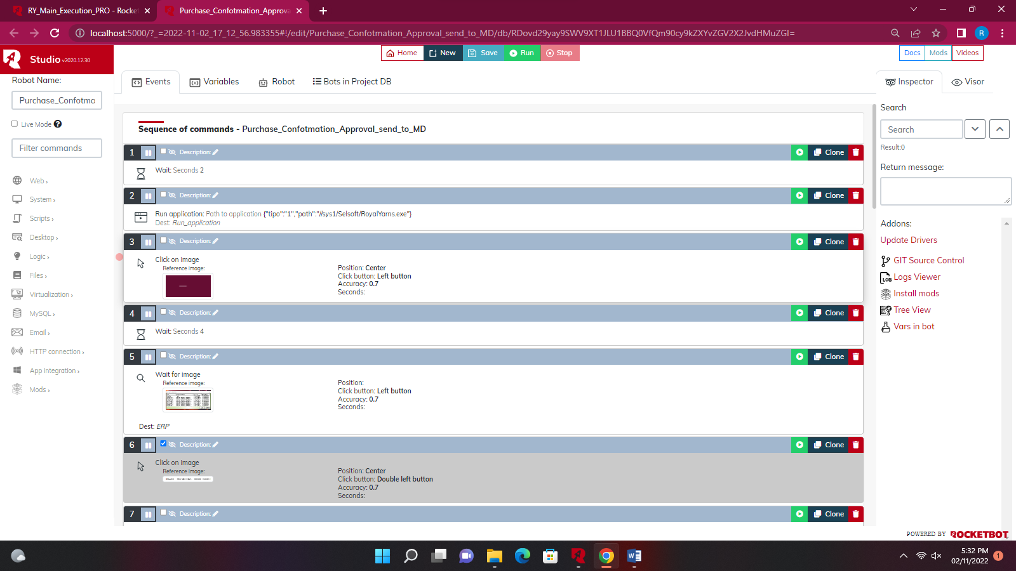

* **Purchase_Conformation_Approval_Pro**

**When the email is received from the MD with the approval the bot detects the approval email from the MD and import the approved data of enquiry. And the status gets updated from ‘10’ to ‘11’.**

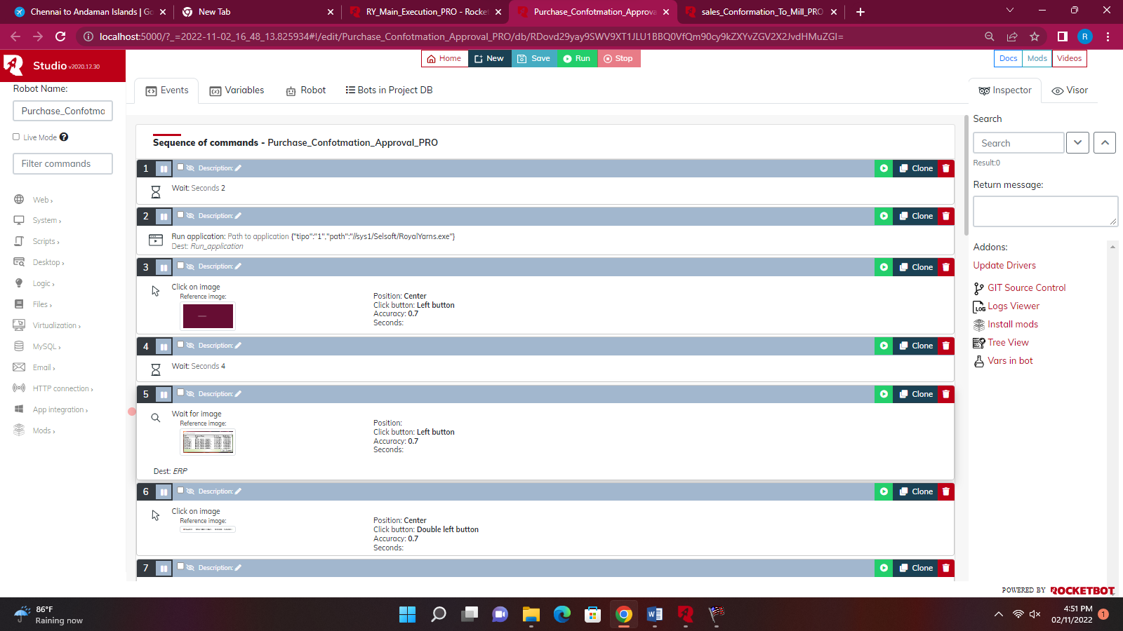

* **sales_Conformation_To_Mill_PRO**

**This bot reads enquiry items with the status of ‘11’ from the database. And executes the Sales Confirmation Screen in the erp. And the status gets updated from ‘11’ to ‘12’.**

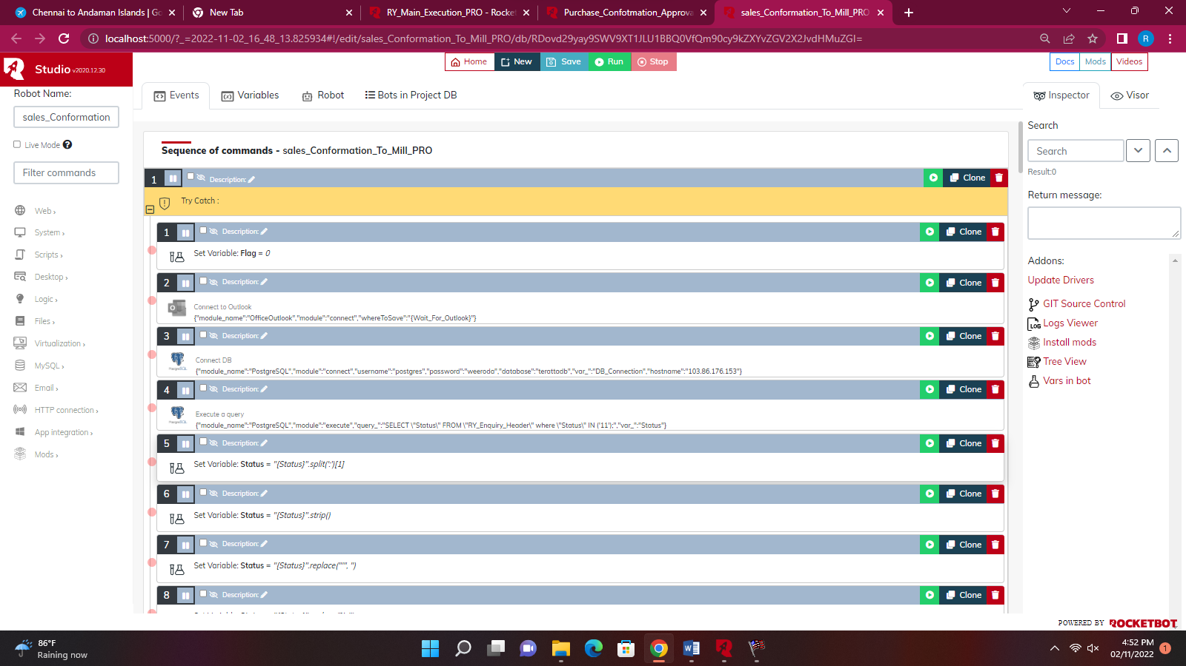

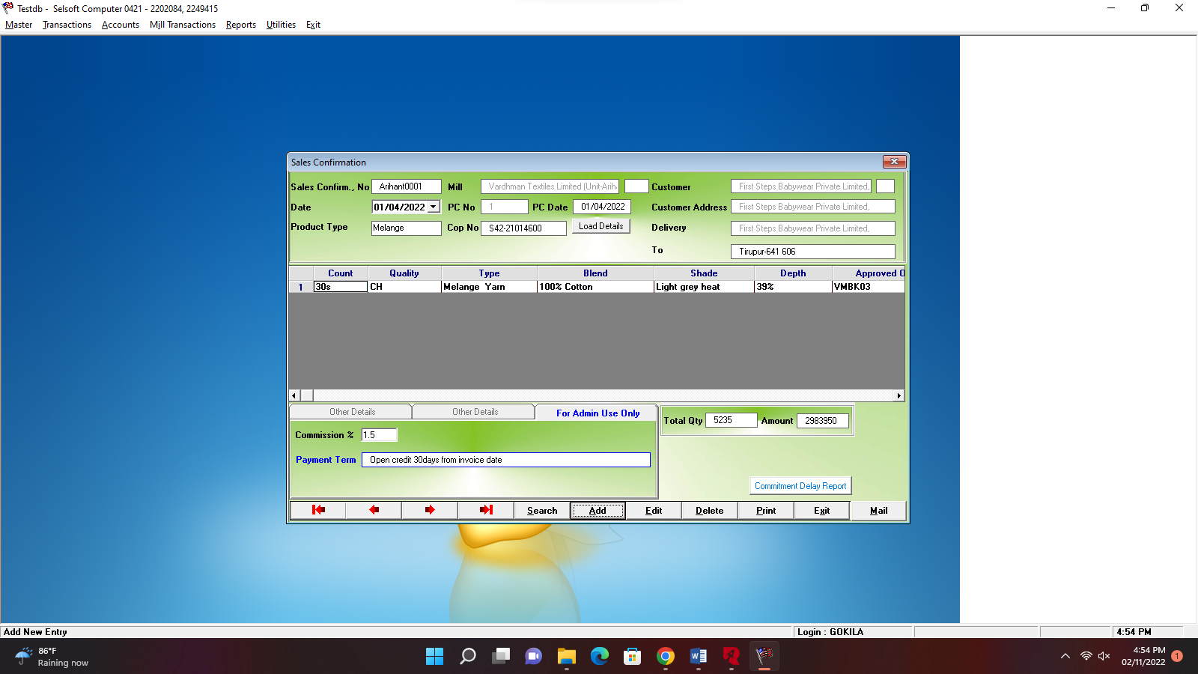

* **COP_NO_Update_PRO**

**This bot reads enquiry items with the status of ‘13’ from the database. And update the cop no received from the supplier in the Sales Confirmation Screen in the erp. And the status gets updated from ‘13’ to ‘14’.**

